Week 6 resources:
Create Thumb Balls that would help encourage conversation skills so I laid out a bunch of conversation starter questions for the students to choose from. We read all the options to the students and let them choose the 6 they wanted to write on their personal thumb ball.

Once all the beach balls had been written on we practiced a round of Thumb Ball with each one of the student's personalized ball so they got to see the game in action one more time and it also had more meaning to them when it was their own questions!
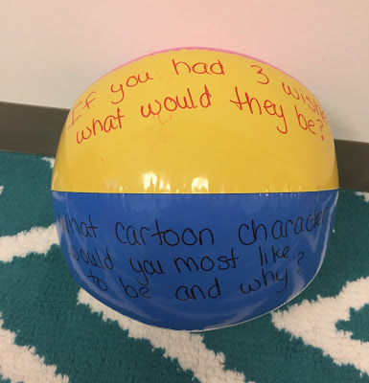
Questions such as:
Share 3 things you like about yourself
What has been the happiest day of your life?

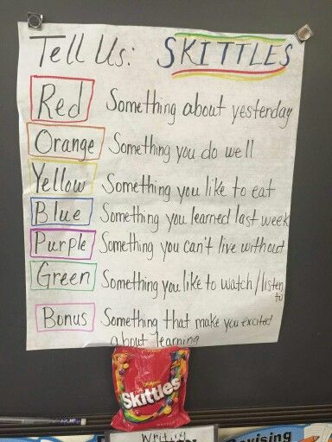
Pick a skittles then use the colour code to answer the questions

